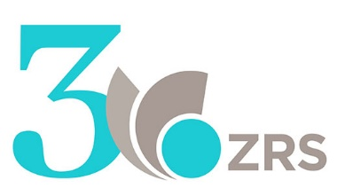

are cordially inviting you to the

2nd Scientific Conference
titled
CORPORATE SOCIAL RESPONSIBILITY,
AS THE RESPONSIBILITY OF DIRECTORS
in Euro-Mediterranean Region,

in Current and Future Green and Digital Transformation

in Koper, Slovenia on
September 26, 2024

Location: Centre for Humanities (Kreljeva 6, Koper, Slovenia

SUMMER CALL FOR PAPERS



Dear Ladies and Gentlemen,

We are pleased to invite you as an author and/or participant/attendee to the 2nd Scientific Conference CORPORATE SOCIAL RESPONSIBILITY, AS THE RESPONSIBILITY OF DIRECTORS in Euro-Mediterranean Region, in Current and Future Green and Digital Transformation, to be held in Koper, Slovenia, September 26, 2024.

We invite you to present your original papers and contributing to the creation of a responsible society. We are interested in your research of local and/or global sustainability research topics/area, in scientific or applied legal visions of green and digital transition, with the focus on responsibility of directors/executive leaders.

Enclosed, you will find the instructions and template for paper submission for the conference.

A one-day scientific conference, on September 26, 2024, from 9 a.m. to 5 p.m., with renowned international guests will take place in the Centre for Humanities (Kreljeva 6, Koper, Slovenia) in Koper, Slovenia, EU. The 2nd Scientific Conference on Corporate Social Responsibility (CSR) will be international, in English, available also online.

The organizer of the conference is the public institute Scientific Research Center Koper, and the co-organizers are the EMUNI University and IRDO – Institute for the Development of Social Responsibility, all from Slovenia, EU.

The conference is part of a research project titled SOCIAL RESPONSIBILITY OF COMPANIES AS THE RESPONSIBILITY OF DIRECTORS (ARRS registration number: J5-4582), project holder: Scientific Research Center Koper - Law Institute.

We look forward to your participation and contribution to this important conference. Sincere thanks in advance for your interest to participate!

With kind regards,

Prof. Dr. Rado Bohinc,
President of the Conference Program Committee,
Scientific Research Center Koper & EMUNI University

Science and Research Centre Koper,  Law Institute | SUMMER CALL FOR PAPERS  2nd Scientific Conference  CORPORATE SOCIAL RESPONSIBILITY,  AS THE RESPONSIBILITY OF DIRECTORS  in Euro-Mediterranean Region,  in Current and Future Green and Digital Transformation, in Koper, Slovenia  September 26, 2024

CONFERENCE PRESENTATION

The conference titled “CORPORATE SOCIAL RESPONSIBILITY, AS THE RESPONSIBILITY OF DIRECTORS in Euro-Mediterranean Region, in Current and Future Green and Digital Transformation” will have a special focus on legal incentives and obstacles to the realization of corporate social responsibility in Slovenia, the EU and globally, with focus on the Euro-Mediterranean Region.

Corporate social responsibility will be analysed in terms of stakeholder obligations and directors' responsibilities.

Similar as in year 2023, also this year following topics will be presented in more detail:
- non-financial reporting and corporate social responsibility according to EU law and according to national legislation,
- experiences and theoretical perspectives, as well as
- actions on due diligence implementation regarding sustainability and human rights, on the conduct of directors and on disclosures related to sustainability, and on taxonomy and
- exploring the future trends and highlighting innovative approaches and identifying best practices.

Legal compliance - the criteria of social responsibility from ESG (ESRS) topics will be presented too.

We would like to invite authors to present some of their research results on digital and green transition - legal and practical issues, challenges and their future perspectives. In addition to theoretical sources, legislation and case law, the different legal and strategic bases will be used.



CONFERENCE THEMES
Suggested conference themes for green and digital transformation are:
- Social responsibility and green transformation, sustainability standards, certification schemes and tools.
- Social responsibility in legal directives and practice.
- Artificial Intelligence as tool for sustainability.
- Social responsibilities and digital transformation in theory and practice.
- Sustainability Educational programs, educational projects, tools.
- Other possible topics (accordingly to your suggestion, but in line with general theme of the conference).
INVITATION TO AUTHORS/ PARTICIPANTS
We kindly invite authors to submit original contributions (abstracts/papers), to be presented at the conference during the discussion section. After the conference, a monography will be published, featuring comprehensive contributions.
Important dates:
- July 16, 2024 – Call for Papers.
- August 28, 2024 – Submission of Abstracts of Papers.
- September 1, 2024 - Author Contributions Confirmation.
- September 5, 2024 - Announcement of the Conference Program.
- September 15, 2024 – Author Final Papers Submission.
- September 26, 2024 - Conference Event (Paper Presentation at the Conference in Koper, Slovenia or online).

We kindly ask you to:
- Send us your Abstracts of Papers and to contribute to the conference in September 2024 in Slovenia (Koper).
- Send us your registration form (enclosed), filled in with your data.
- Use the enclosed template for your abstract and paper submission.
- Pay the conference fee before the conference start.
- Present your Paper at the Conference on September 26, 2024.
Selected papers will be published in the conference proceedings.

For some best papers we will invite authors to develop them to the special part of the scientific monograph published at IGI Global or some other scientific publication.

For all additional information please contact:
- Anita Hrast, M.Sc., Organizational Committee, anita.hrast@zrs-kp.si.
- Please send us your registration form and abstract proposal to anita.hrast@zrs-kp.si.

More about our work you can find here:
- https://www.zrs-kp.si/en/sodelavec/dr-rado-bohinc/
- https://www.zrs-kp.si/en/institutes-and-units/law-institute/
- https://www.zrs-kp.si/novice/druzbena-odgovornost-podjetij-kot-odgovornost-direktorjev/

CONFERENCE PROGRAM - TOPICS AND INVITED SPEAKERS - TBC
Hour | Speaker / Topic (September 26, 2024) – online & onsite
8:30 | Registration, morning coffee
9:00 | Introduction  - Dr. Rado Pišot: Opening Speech  - Dr. Rado Bohinc: Conference Introduction
9:10 | Guests of honour  - TBC
9:30 | International guest speakers  - TBC
10:30 | Discussion with guest speakers
10:45 | Conference themes - presentation of papers (1):  - TBC
11:45 | Lunch & networking
12:30 | Conference themes – presentation of papers (2):  - TBC
14:30 | Coffee break & networking
15:00 | Conference themes – presentation of papers (3):  - TBC
16:30 | 3rd Scientific Conference - Feedforward  - Discussion with Participants and Feedforward
16:45 | Conference conclusions
Remark: The organizers reserve the right to change the program.
CONFERENCE COMMITTEES

PROGRAMME COMMITTEE:  - Dr. Rado Bohinc, President  - Dr. Bojan Tičar, Vice-president  - Dr. Roberto Biloslavo, Vice-president  - DDr. Maja Pucelj, Vice-president  - Dr. Rado Pišot, Director of ZRS Koper, Member  - Dr. Urša Golob Podnar, Member  - Dr. Andreja Primec, Member  - Dr. Dušan Jovanovič, Member  - Dr. Borut Bratina, Member  - Dr. Morten Huse, Member  - Dr. Parameswar Nayak, Member  - Dr. Jeff Schwartz, Member | ORGANISATIONAL BOARD:  - M.Sc. Anita Hrast, President  - Dr. Bojan Tičar, Vice-President  - Rade Trivunčević, Member  - Mateja Krmelj, Member  - Nika Štravs, Member  - Peter Čerče, Member  - Robert De Lucia, Member  - Alenka Obid, Member

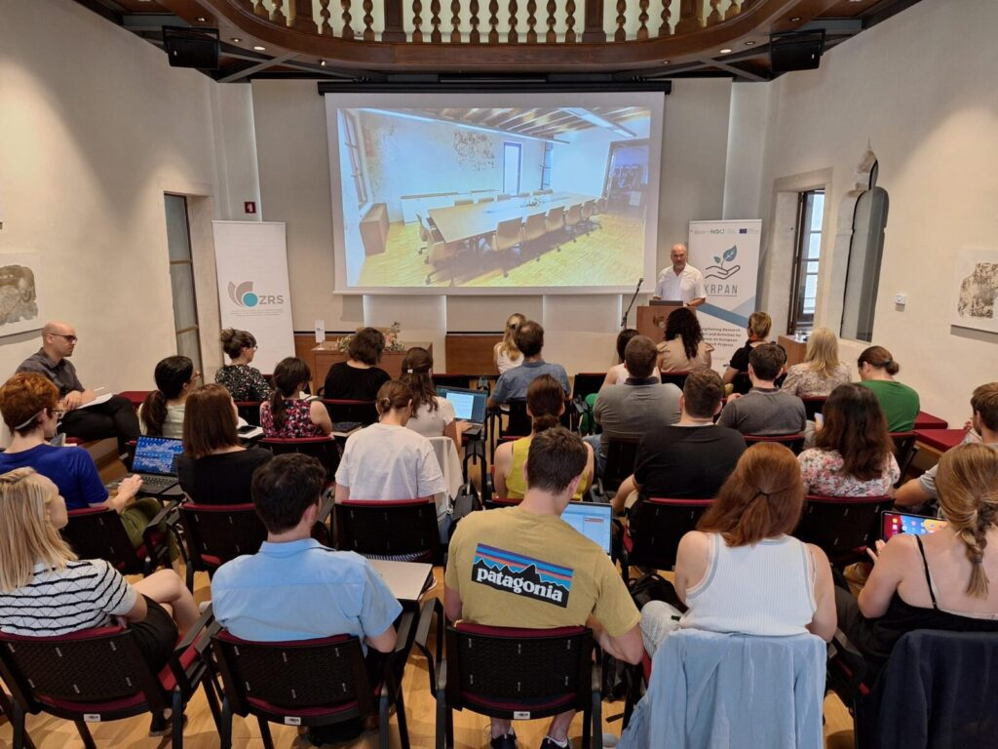

CONFERENCE FEE & REGISTRATION
 | REGISTRATION AND PAYMENT in EUR
PARTICIPATION | BEFORE September 1, 2024 | AFTER September 1, 2024
Invited authors | For free | For free
Author of the paper | 150 | 200
Participant without paper | 180 | 230
Member of partner organization for authors & participants (20 % discount) | - 120 (author)  - 144 (participant) | - 160 (author)  - 184 (participant)
Student | 50 | 70
Online or onsite registration:
- Participants onsite have additional 20 % discount on the conference fee.

Conference fee includes:
- Attendance to lectures at the conference.
- Conference programme with conference proceedings.
- Presence at Conference on September 26, 2024 (onsite or online).
- Coffee breaks and lunch during the conference.

Payment due date and instructions:
- The registration fee must be paid no later than on September 1, 2024.
- Proof of payment: Participants will receive an invoice as proof of payment of the registration fee after the conference concludes.

Instructions for payment of the registration fee:

Legal entities (companies, institutions, associations):
- Based on your registration (and issued order form), we will issue a pro-forma invoice, which must be paid by September 1, 2024, to qualify for the discounted registration fee (contact: finance@zrs-kp.si).
- Bank details for payment can be found below.
- After payment of the registration fee, you will receive an invoice for the pre-payment (e-Invoice for the pre-payment).
- After the conference, you will receive an invoice (e-invoice) for the paid registration fee.

Personal transaction or international payment:
- In case of required pro-forma invoice, please send your request to: finance@zrs-kp.si, and we will issue a pro-forma invoice.
- Bank details for payment can be found below.
- After the conference, you will receive an invoice for the paid registration fee.
Data for payment of the conference fee:
- Organizer’s name: ZRS KOPER, Garibaldijeva 1, 6000 KOPER, Slovenia
- SUBJECT: Surname of the participant/participants
- Bank data:
- IBAN: SI56011006000053955
- SWIFT: BSLJSI2X
- BANKA: Banka Slovenije
- Bank Address: Slovenska 35, 1505 Ljubljana

Cancellation policy
For written cancellations received before September 10, 2024, 50 % of the total registration fee will be charged.
No refunds will be provided for non-participation without prior cancellation.

Additional information:
- The official language of the conference is English.
- Invited lecturers are waved from paying the conference registration.
- All other authors pay the conference registration fee as stated above. An invoice will be issued based on your payment.
- All participants must register for the conference with an application form and pay the registration fee (exempt invited authors).

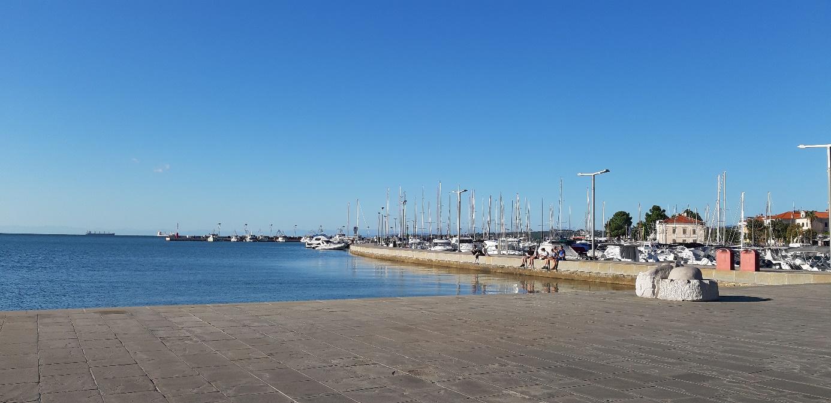

ORGANIZATIONAL INFORMATION

Conference date: Tuesday, September 26, 2024

Conference venue:
Conference will be held at the Centre for Humanities - SCIENCE AND RESEARCH CENTRE KOPER (Kreljeva 6, Koper, Slovenia) and online.

Official language: English

Co-financer:



Organizer Info:
SCIENCE AND RESEARCH CENTRE KOPER
Garibaldijeva 1, SI - 6000 Koper, Slovenia
+386 (0)31 344 883, anita.hrast@zrs-kp.si

Conference contact:
- Anita Hrast, M.Sc., Organizational Committee, anita.hrast@zrs-kp.si

Organizer:
- Scientific Research Centre Koper, Slovenia

Co-organizers:
- EMUNI University, Slovenia
- IRDO – Institute for the development of Social Responsibility, Slovenia



